**CENWW-OD-DWR 10 January 2017**

**MEMORANDUM FOR THE RECORD - 16 DWR 01 MFR Fish Loss Tailrace Dworshak Dam**

**SUBJECT: Fish Loss Tailrace Dworshak Dam UPDATE (1-10-17)**

1. **Incident Description:**

Notification was received by Dworshak Dam personnel at approximately 1530 hours on Wednesday, November 9 that there were numerous dead or dying fish in the tailrace. A fisherman present on the fishing wall had witnessed that large numbers of fish would swim towards the turbine when unit flow stopped and later observed fish carcasses and heads being carried away when the unit was restarted. From the Dworshak fishing wall, Project Operations staff observed a small number (less than 10) of fish swimming in erratic patterns. Project staff observers also noted silver or white objects laying at the bottom of the river, but the lighting in the canyon on that day did not allow for identification of the nature of the objects. Fishermen also mentioned they had seen a few dead fish the day before as well (November 8). No further reports were received after November 9 from fishermen. Beginning November 10, investigating project staff were off for Veterans Day holiday and no additional investigation into the problem was conducted until these project staff returned to work on November 14.

NWW District staff in Walla Walla were informed of the incident on November 14 and requested further specific details. NOAA Fisheries was contacted at ~9:30 AM on November 14 of this incident. Follow up observations by boat on 14 November indicate that approximately 200 fish mortalities (presumed adult steelhead) were laying in the tailrace. Many of these mortalities were not visible from the shore due to poor lighting in the canyon and the depth of the water (25’). One fish was recovered and taken by USFWS Fish Health staff to Dworshak Fish Hatchery to determine probable cause of death. Examination by USFWS suggests that contact with structural elements of Unit 2 likely caused the steelhead mortality.

Unit 2 was taken out of service on September 26, 2016 and all fish protection procedures in the Fish Passage Plan were followed and no loss of ESA-listed fish occurred. Powerhouse testing operations that took place November 8 and 9 on Unit 2 likely caused these fish mortalities. The testing occurred after completion of a maintenance upgrade of mechanical to digital governors. Most of the fish killed were either decapitated or had significant damage to their heads and/or gills, which is consistent with damage caused by contact with structural elements. In preparation for the powerhouse testing, tailrace stop logs were removed on November 7 at ~ 3:00 PM, and testing began ~9:50 AM on November 8. This is standard procedure when planning to return a unit to service after maintenance activity. Commissioning the digital governor required that Unit 2 be started and stopped 26 times during this new equipment validation and performance (commissioning) process. To stop a unit, water flow through the unit's wicket gates is shut off but the turbine runner continues to spin, slowing down until it can either be restarted or brakes can be applied. It is possible that as soon as flow stopped, large numbers of fish swam up into the draft tube and came in contact with the moving turbine runner.

Hatchery/Wild Composition

Several options to estimate the breakdown of hatchery and wild fish composition for the 200 steelhead were considered. We are providing a range for the hatchery/wild composition that encompasses all possible estimate methodologies (described below) of 2-47 wild steelhead (1%-23.4%), 153-198 hatchery steelhead (76.6%-99%). All fish lost are listed under the Endangered Species Act (ESA). It is our understanding that loss of these fish has not affected the ability to collect adequate brood stock for area hatcheries during 2016/17.

The first method to estimate the wild fish component utilized the estimated breakdown of rearing type composition at Lower Granite Dam from US v OR TAC reports (2015 Joint Staff Report for Fall Fisheries). Over the last 5 years, percentages for steelhead at Lower Granite Dam has been about 76.6% hatchery, 23.4% wild. This methodology provides a worst case scenario of 47 wild steelhead, as the makeup of steelhead at Lower Granite Dam encompasses the whole of the Snake River basin and is not specific to the B-run steelhead returning to the North Fork Clearwater.

There are unclipped hatchery fish released within the South Fork Clearwater River from Clearwater Hatchery, and into Lolo Creek from Dworshak Fish Hatchery. All hatchery steelhead released into the North Fork Clearwater River are adipose clipped. For the brood years returning to the Clearwater River during 2016-17, the proportions of unclipped fish released are 10% of the steelhead that are now returning as 2-ocean adults and almost 15% of 1-ocean returning steelhead. Since all unclipped fish were released off site (Lolo Creek and South Fork Clearwater), relatively few of them would be expected to be returning to the North Fork Clearwater. These fish would however need to be considered when using Lower Granite counts to estimate the proportion of unclipped hatchery from the wild component.

The second method used the juvenile percentage composition during passage at Lower Granite Dam from the spring to provide a breakdown for estimating the likely adult rearing type proportion of fish lost below Dworshak. Using this methodology, we would estimate 81.3% clipped hatchery, 11.3% unclipped hatchery, and 7.4% wild.

A third method used the trap records from Dworshak National Fish Hatchery. The hatchery collects adult steelhead in the fall (at discrete intervals in October, November and December) to be used for broodstock in the spring. This year they processed fish 18 October and 4 November. During 2016, they collected a total of 1,131 steelhead of which 5 were unclipped. They ponded 327 fish and released the remainder, including all unclipped fish. For just the last sample date, five days before the fish kill event at the dam, they collected 667 steelhead including 4 (0.6%) unclipped fish. Rounding up to 1% unclipped fish suggests 2 wild fish of the estimated 200 steelhead mortalities.

A fourth method was to examine the steelhead creel information collected by IDFG. The week before the fish kill they reported 32 steelhead caught and 5 released (15.6%). If we assume all fish released were unclipped, this suggests 31 of the 200 dead steelhead could have been of wild origin. The creel information did not indicate if the fish were released because they were unclipped or because they were small "jack" steelhead which anglers often do not keep. From the Dworshak Fish Hatchery trap data, 31% of the fish in the North Fork were in the size range of 1-ocean returning steelhead. We also know there may be a difference in likelihood of a fish to “bite” between the various rearing types.

Because no single methodology could provide an unbiased estimate, we have provided a range rather than a point estimate for the hatchery/wild composition of fish lost.

1. **Incident Investigation:**

NWW and Dworshak project staff analyzed potential causes of this incident and discussion of their findings were inconclusive as to the exact mechanism that caused this incident. The engineering investigation of operational conditions during the commissioning process found the most likely mechanism for these mortalities was that the adult steelhead had access to a spinning turbine runner (200 rpm). Depending on tailrace elevation, which varies from 968 to 1003.4 ft, the runner is either partially or fully submerged when there is no flow through the wicket gates. During the time when this incident occurred, the tailwater was at elevation 971. In addition, we wanted to clarify that Unit 1 was in operation during this incident and that routinely we have periods of speed no load (SNL) during unit startup and shutdown. Typical time of SNL during startup and shutdown is 1-5 min. The high rate of decapitation (estimated at 90%) suggests that fish were coming into contact with a spinning turbine runner after swimming into the draft tube from the tailrace. This estimated decapitation rate for the impacted steelhead is taken from underwater camera observations by project staff on November 15 (pictures attached below).

The new digital governors allow for a much faster unit ramp time during startup than the original mechanical governor systems. If contact with the spinning turbine runner occurred, it’s not possible to identify if it occurred during the rolling stop, the rapid start phase, SNL or even during depress operation. The available evidence suggests that the combination of repeated rolling stops, numerous intervals of SNL, and faster wicket gate response resulted in this incident. These operations, combined with large numbers of fish holding in the tailrace without flow conditions to impede access into the Unit 2 draft tube, likely created conditions injurious for adult steelhead.

While NWW postulates that contact with the spinning turbine runner may have caused the mortalities observed in this incident, similar routine maintenance activities typically occur during this time of year, and require about 4-6 starts and stops with no observed mortalities in the past. Because of this fact, future remedial operational actions are focused primarily on counteracting actions taken during the Unit 2 commissioning that were abnormal. Maintenance occurs at this time of year because of the reduced risk of creating high TDG levels in the North Fork Clearwater. Additionally, no known fish mortalities were observed with comparable governor commissioning procedures with Unit 3 in March of 2016 that required approximately the same number of starts and stops. A potential difference in outcome is that Unit 3 is a much larger unit with a naturally slower mechanical start rate, and larger openings in the runner for fish passage. Also, the timeframe for the Unit 3 testing was in March and it is likely there were fewer steelhead in the tailrace area of the dam to be affected as well.

Another maintenance project on Unit 2 was completed during this same unit outage [Sept 23 - Nov 7, 2016]. The wicket gate seals were replaced to reduce leakage and enable operations to depress the unit to provide voltage stabilization to the transmission system by running the unit as a motor rather than a generator. When a unit is in depress mode, air is delivered into the runner area which pushes water away from the blade. A gap of six feet is maintained between the turbine and the tailrace water level. An air valve is used to maintain the six foot gap. It is not believed running the unit in depressed mode on November 8 and 9 caused fish mortality as there is no evidence to suggest that there were any issues with the depression system that would have collapsed the air gap to bring water and fish up into the spinning runner. Witness accounts of dead fish being discharged were not consistent with when the unit was operating in depression. In addition, this depress operation is routinely used on Unit 3 and has not created any similar mortality incidence.

Total Dissolved Gas (TDG) impacts were also considered as a possible cause but found not likely given the types of injury that were observed.[1]

Despite the inability to conclusively determine which operation was the root cause of this incident, measures to mitigate all possible mortality mechanisms are being suggested for future testing.

The Corps will continue to coordinate with regional state and federal agencies, tribes, and other entities as additional factual information is gathered and disseminated. To prepare for future maintenance activities related to similar ongoing maintenance work on Unit 1, the Corps will coordinate closely with Regional fishery managers to explore solutions that will avoid future incidents to adult steelhead prior to planning any commissioning testing for Unit 1. Unit 1 is expected to have the digital governor maintenance upgrade completed in early January 2017, and will at that time require commissioning testing.

1. **Findings**:
2. Species – approximately 200 fish (presumably Snake River steelhead)
3. Origin – Unknown but estimated to be primarily hatchery steelhead due to close proximity to two mitigation hatcheries [2-47 wild steelhead (1%-23.4%), 153-198 hatchery steelhead (76.6-99%)].
4. Length – Unknown
5. Marks and tags – Unknown
6. Marks and Injuries found on carcass – Decapitation, head and gill injuries.
7. Cause and Time of Death – Most likely contact with spinning turbine runner, with exposure to turbulence and cavitation during Unit 2 commissioning tests on November 8 and 9, 2016.
8. Future and Preventative Measures – Corps proposes implementing several actions:

1) During commissioning of the digital governor, we will implement a modified commissioning plan that will meet the intent of the commissioning by testing all required control signals, alarms, and trips, but have eliminated tests that unnecessarily duplicate testing already performed on Unit 1. The revised commissioning plan will include the following features to make it mimic a more normal operation:

A. A portion of unit start/stop sequence tests will now be done before the unit is watered-up.

B. The revised procedure start/stops are reduced to only 6-7 full stops with air depression, and no rolling start/stop sequences.

C. Since Unit 2 has been successfully commissioned, the portions of commissioning at speed-no-load (SNL) can be postponed until a time when there are low numbers or no fish in the tailrace.

2) During normal or trip startup or shutdown sequences, utilize the air depression system either in advance of opening (startup) or after closure of the wicket gates (shutdown). The depressing air system takes about 30 seconds to 1 minute to lower the draft tube water elevation to about 6 feet below the runner. Fish will be prevented from contacting the runner in less time than that, as soon as the water level is below the runner. This presents a low risk option for avoidance of fish impact during both startup and shutdown sequences while undergoing these commissioning tests, as the air creates a physical barrier from the runner. It also presents low risk to mechanical equipment damage, given the following conditions are met:

A. Ensure the thrust bearing high pressure lift system is engaged.

B. Ensure there is adequate seal water to the turbine’s seal rings.

Engineers have evaluated the short term risk as minimal associated with repeated operation utilizing air depression for the purpose of these commissioning tests.

3) Corps will have a biologist onsite to monitor for any mortality event and stop testing immediately, should it occur for commissioning testing of Unit 1.

4) Explore creating flow barriers in the tailrace to discourage schools of fish from reaching the unit under commissioning. This type of operational scenario would be variable specific to project outflow and unit availability.

5) Coordinate more expediently with Regional fishery agencies following Fish Passage Plan guidance for notification on incidents which have impacted fish.

6) Add language to Fish Passage Plan to institute remedial actions identified in this document and any that are developed in the future to avoid recurrences of a similar incident.

**Pictures and Graphs:**

Figure 1. TDG Saturation Plots from the Ahsahka Monitoring Station during Unit 2 Tests

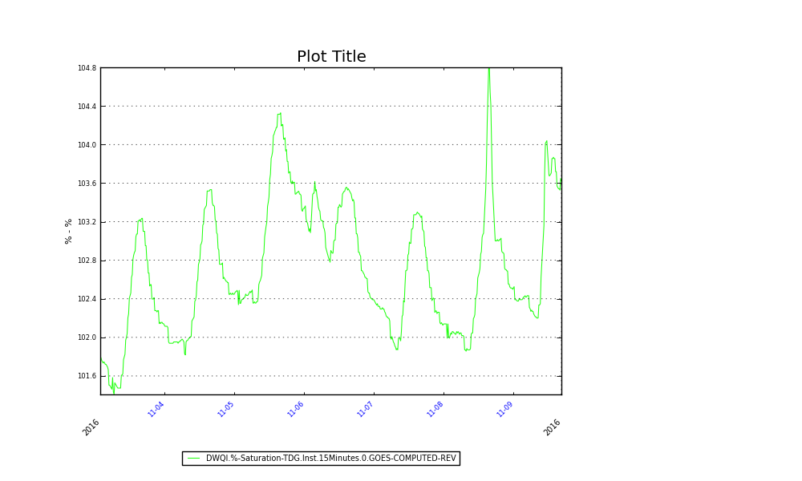

Figure 2. TDG Monitoring Data from Ahsahka Monitoring Station, November 2 – 9, 2016.

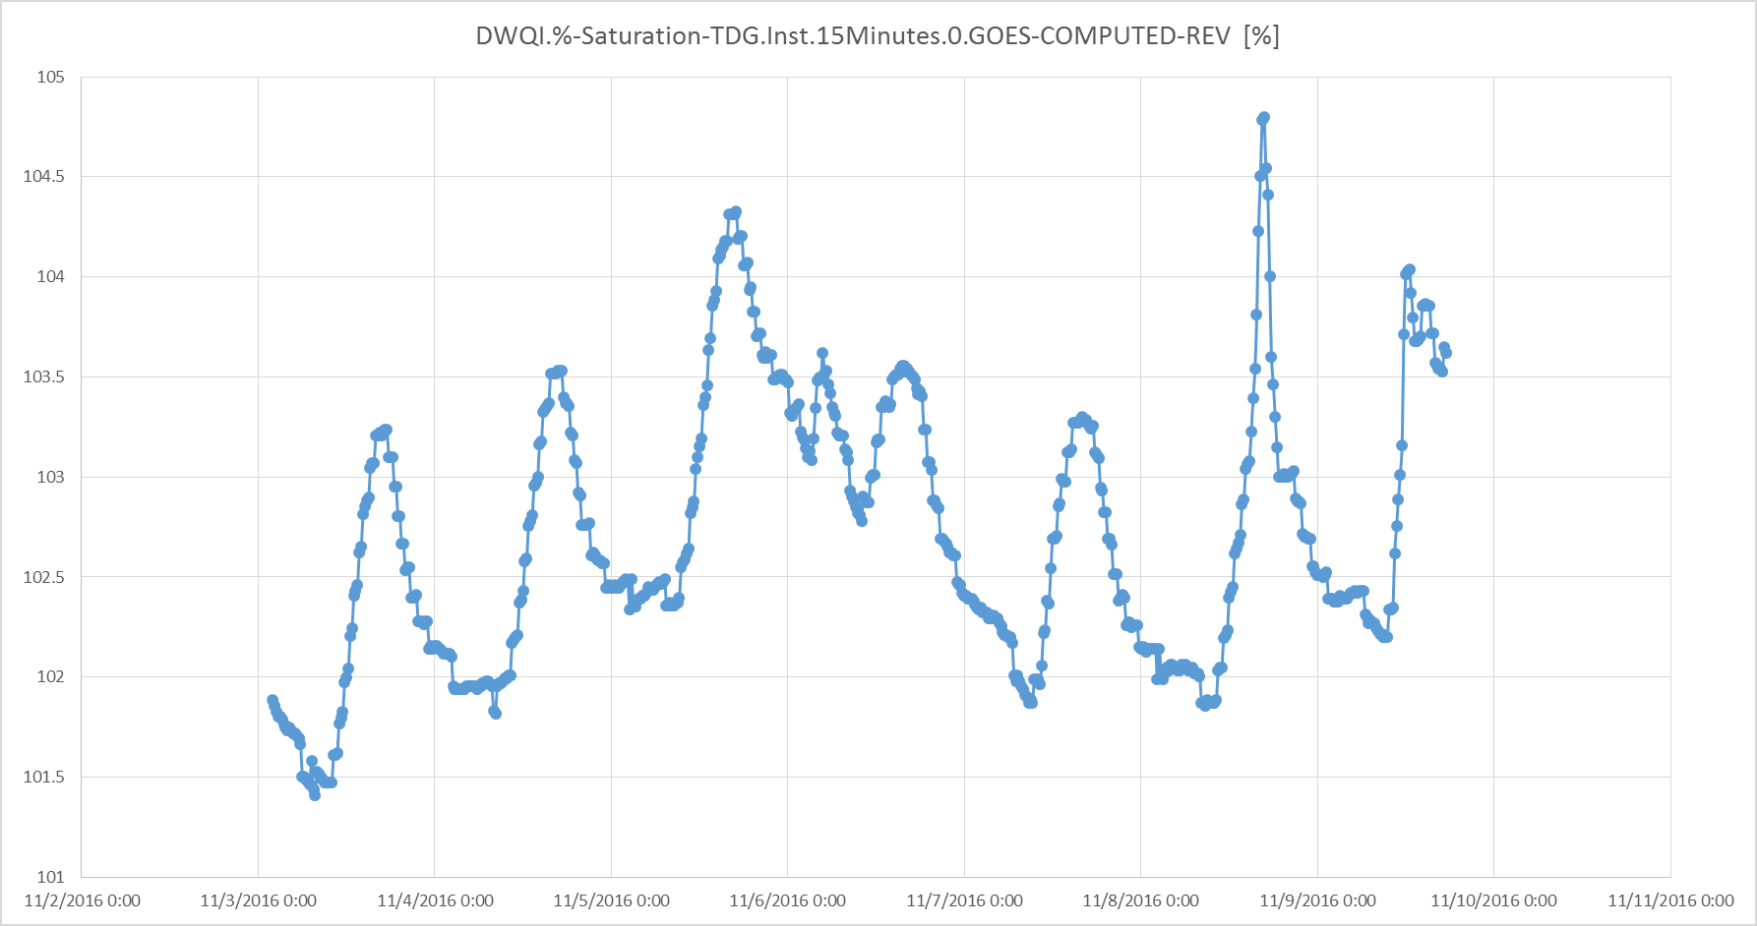

Photo 1. Fish Mortalities observed in tailrace of Dworshak Dam – 14 Nov 2016.

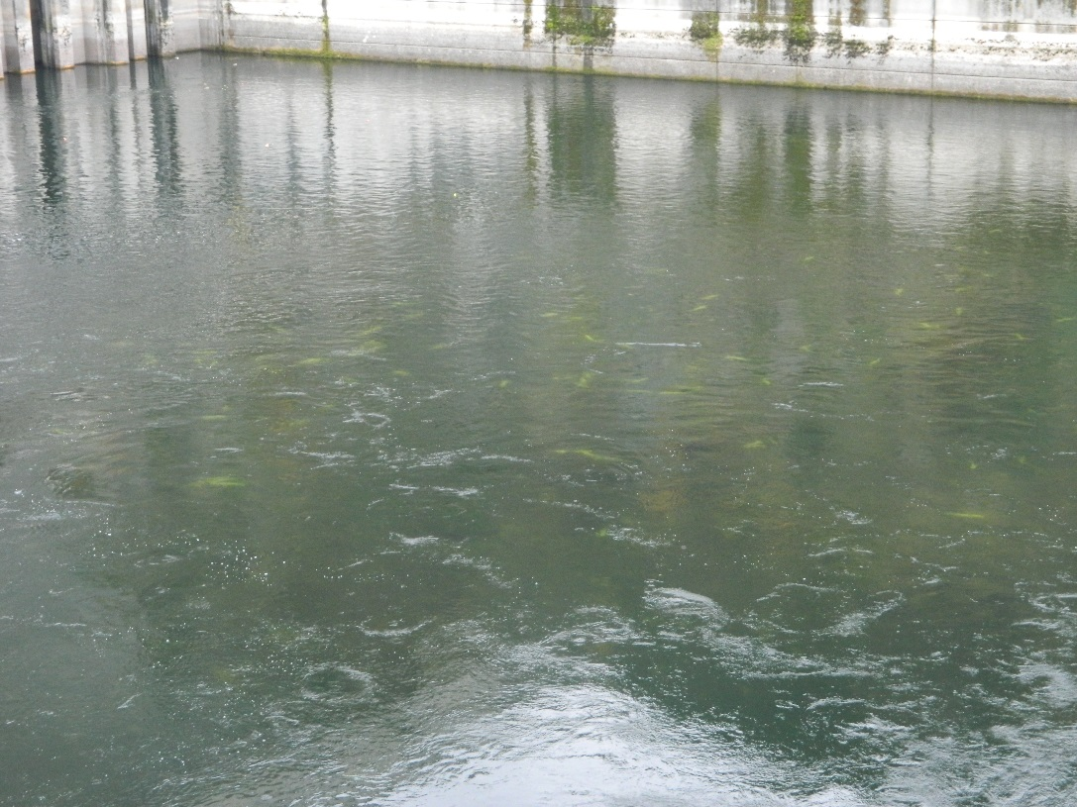

Photo 2. Fish Mortalities observed in tailrace of Dworshak Dam – 14 Nov 2016.

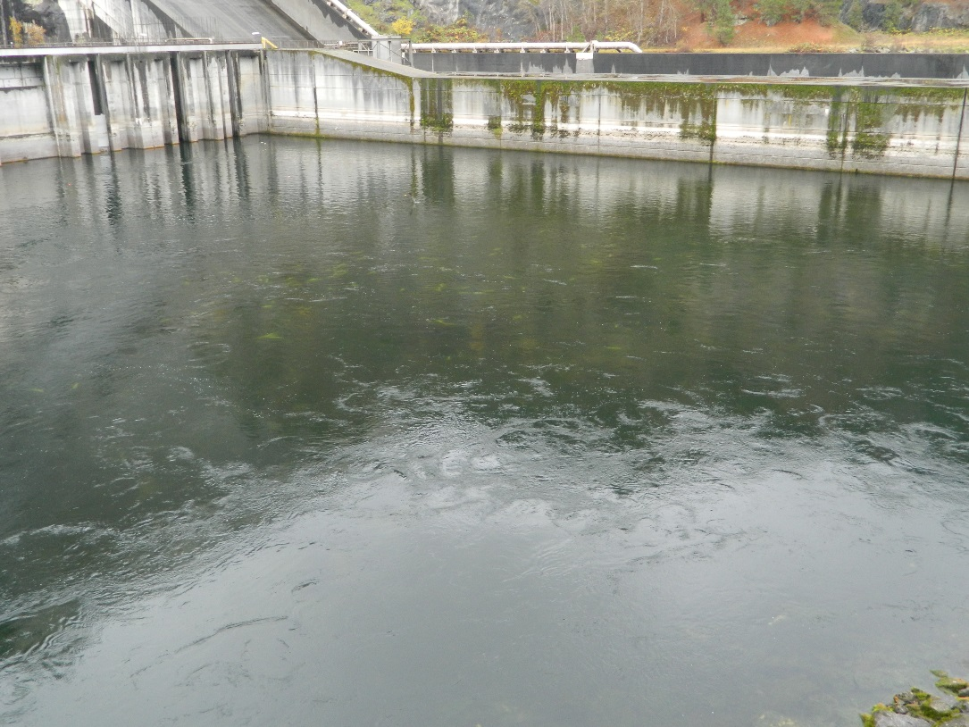

Photo 3. Fish Mortalities observed in tailrace of Dworshak Dam – 14 Nov 2016.

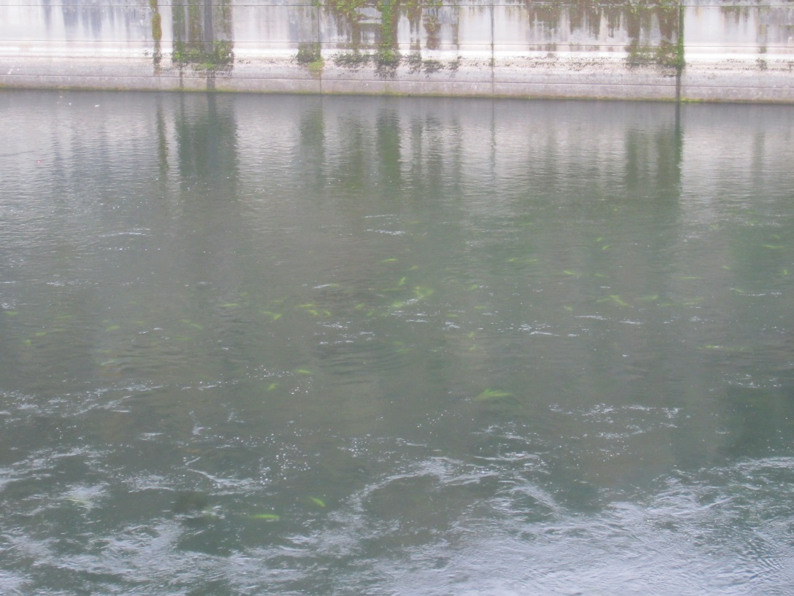

Photo 4. Fish Mortalities observed from boat in tailrace of Dworshak Dam – 15 Nov 2016.

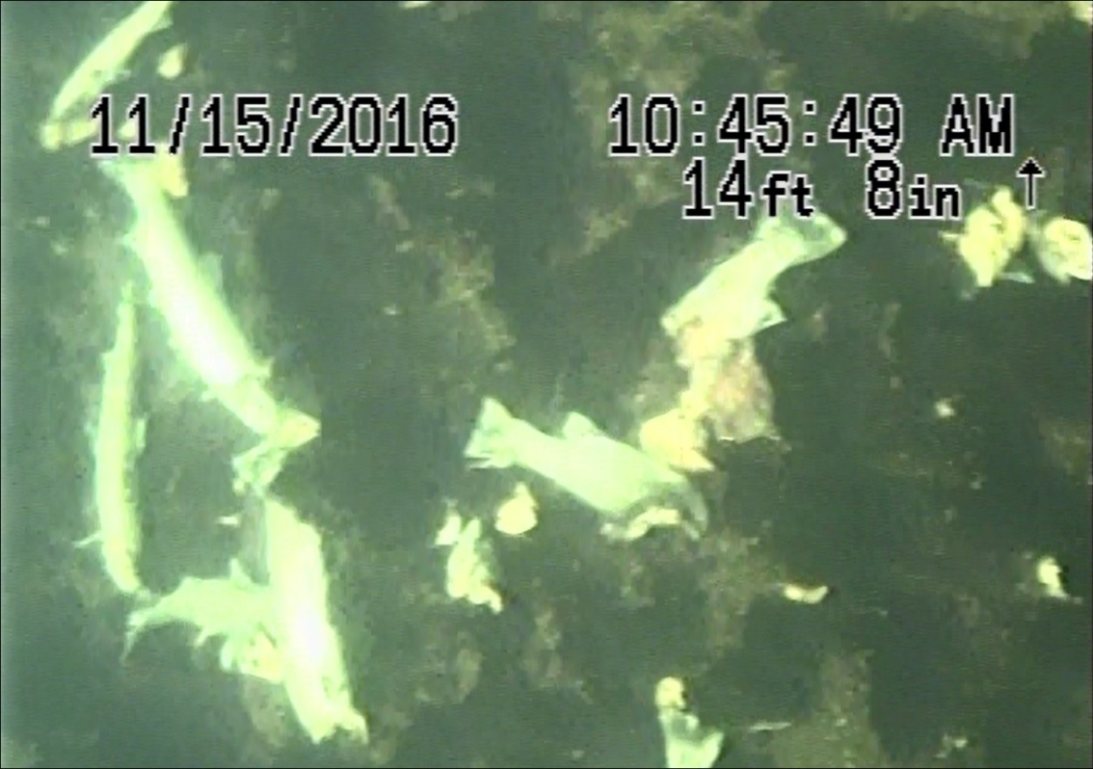

Photo 5. Fish Mortalities observed from boat in tailrace of Dworshak Dam – 15 Nov 2016.

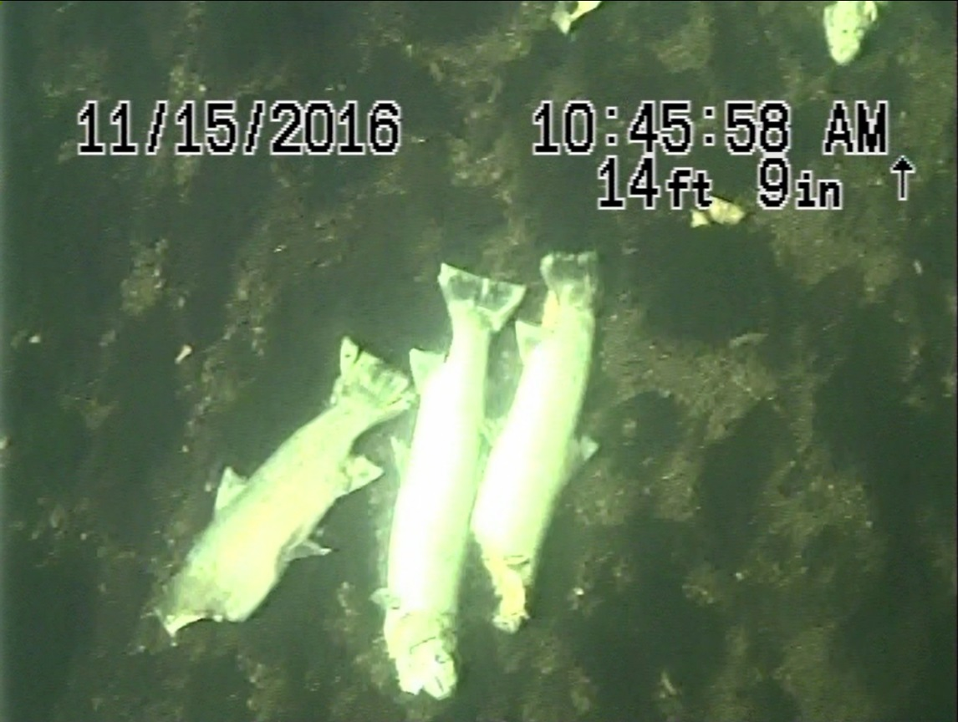

Photo 6. Fish Mortalities observed from boat in tailrace of Dworshak Dam – 15 Nov 2016.

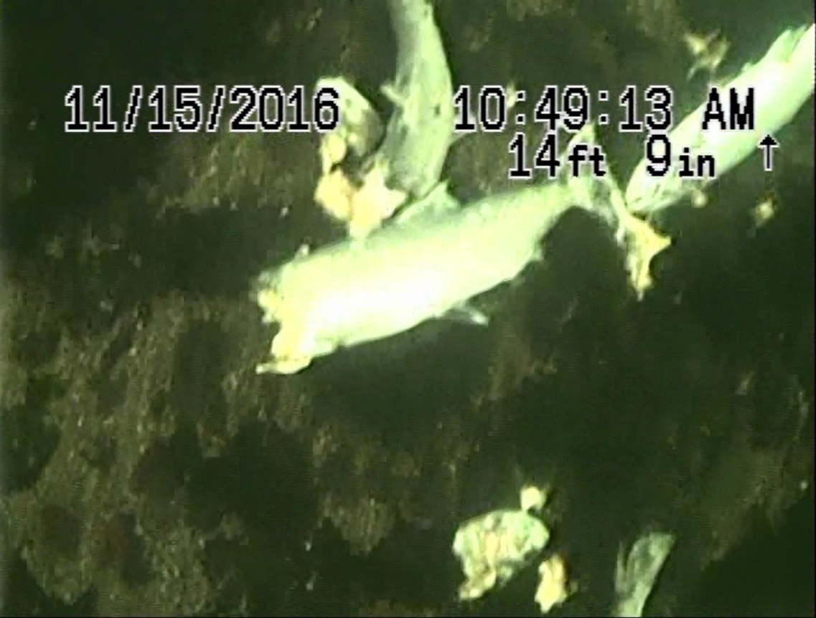

1. TDG data pulled from the Ahsahka station gauge never exceeded 110% during the course of unit testing.